# Business Etiquette for the Modern Workplace

When someone tells his name, to remember it repeat the name in followed up conversation.

When introducing two persons together, introduce the one first who is more senior.

While greeting someone, stand-up from your chair if you are sitting.

If you are audio-only call, announce your name before you speak. If someone ask question, address them by their name.

Text don’t always require an instantaneous response.

You can’t always control other people’s behavior, but you can control your own.

# Microsoft Word Foundations

The MS Word desktop app has most features specially layout and formatting.

We can see and apply all type of styles not just recommended ones like headings –

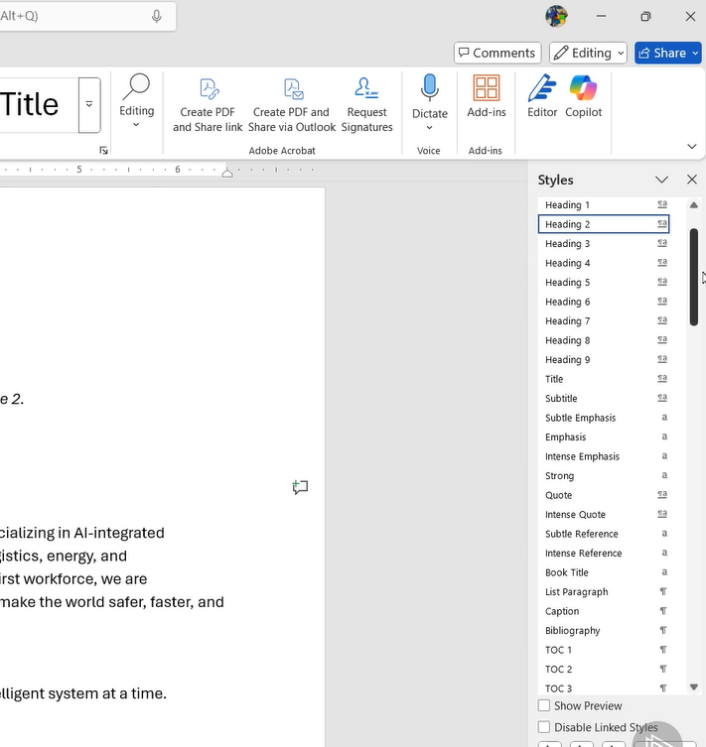

We can apply custom bullet styles –

We can indent first, last, all lines using ruler –

Use shift+F1 to reveal formatting pane

Keyboard shortcut – Ctrl + Spacebar remove all character level formatting, Ctrl + Q remove all paragraph level formatting.

Putting page number and table for contents specially useful while working on document in collaboration manner –

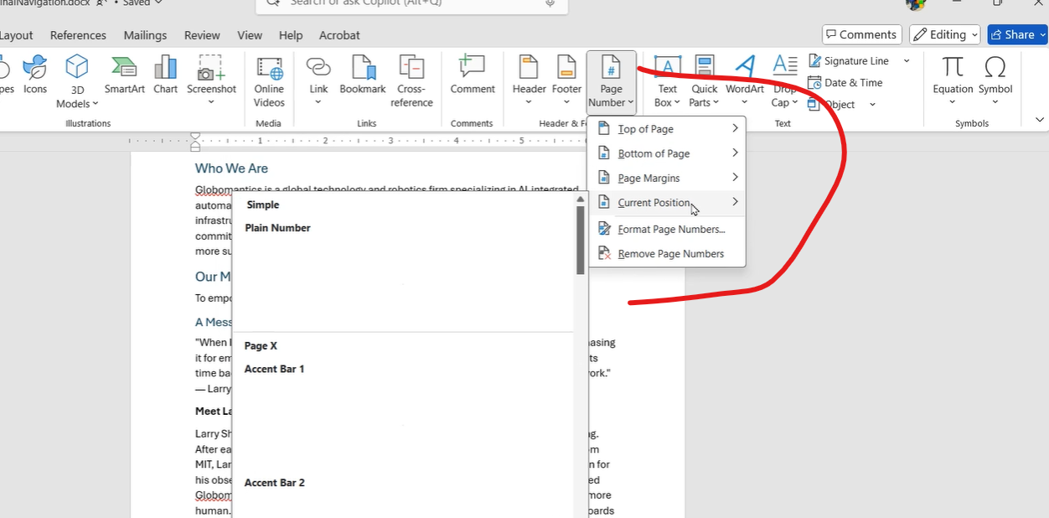

Visual content should support, not distract from the content.

Inserting smart art –

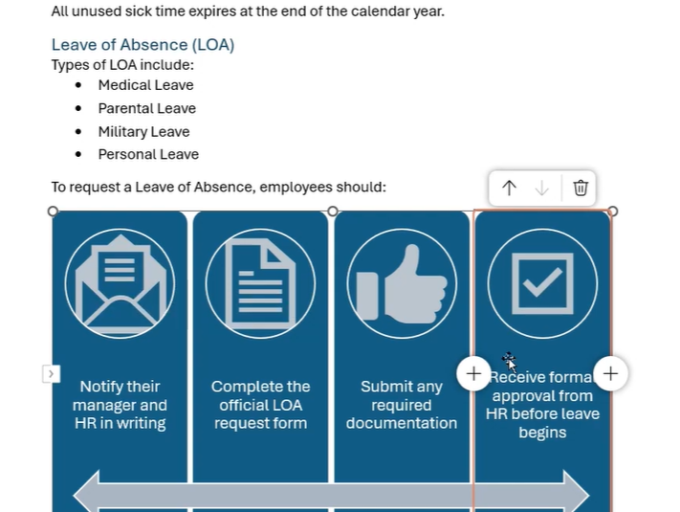

We can remove the background from the image –

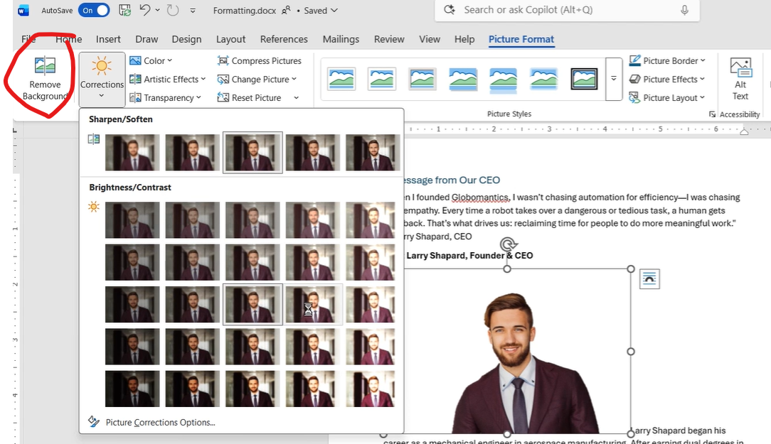

We can control the image positioning using the wrap text, by default the image will be inline with the text –

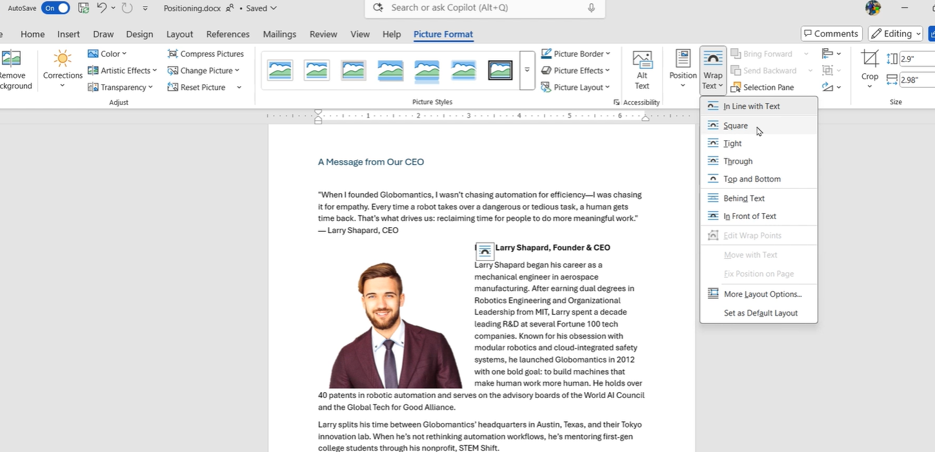

We can also move the image with text or make the image position as fixed –

We can also use the below alternate option for image positioning –

Best practice – like in below case then bullet list doesn’t stand out with important information, we should use tables –

We can do it easily by using Convert Text to Table option –

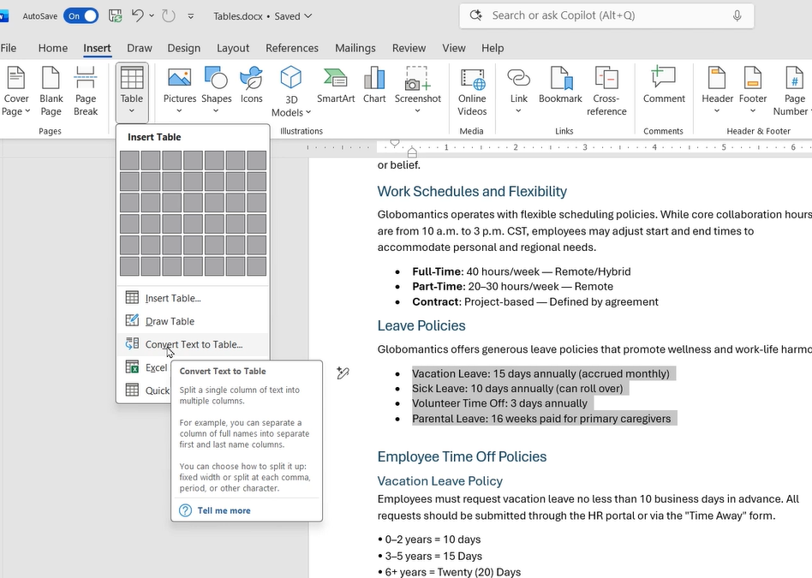

We can create, choose custom color templates on the document by below option –

Create the LinkedIn cover photo like this –

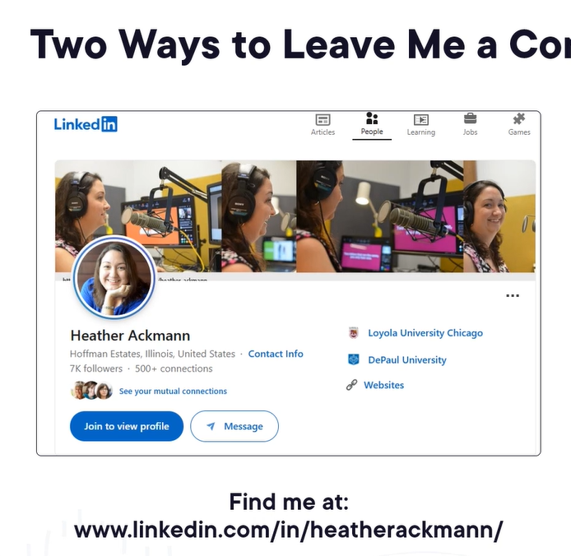

## How to Speak

"Your success in life will be determined largely by your ability to speak, your ability to write, and the quality of your ideas. In that order."

Start

1. Do not start a talk with a joke.

2. Promise - Tell them what they gonna learn at the end of your talk.

3. Cycle – make your idea repeated many times in order to be completely clear for everyone.

4. Make a “Fence” around your idea so that it can be distinguished from someone else’s idea.

5. Verbal punctuation – sum up information within your talk some times to make listeners get back on.

6. Ask a question - intriguing one

Place and Time

7. Best time for having a lecture is 11 am.

(not too early and not after lunch)

8. The place should be well lit.

9. The place should be seen and checked before the lecture.

10. The place should not be full less than a half, it must be chosen according to the amount of listeners.

Tools

For teaching.

1. Board – it’s got graphics, speed, target. Watch your hands! Don’t hold them behind your back, it’s better to keep them straight and use for pointing at the board.

2. Props – use them in order to make your ideas visual.

Visual perception is the most effective way to interact with listeners.

For Job Talk. Exposing, Slides

3. Don’t put too many words on a slide. Slides should just reflect what you’re saying, not the other way around. Pictures attracts attention and people start to wait for your explanation – use that tip.

4. Make slide as easy as you can – no title, no distracting pictures, frames, points and so on.

5. Do not use laser pointer – due to that you lose eye contact with the audience. Instead you can make the arrows just upon a slide.

Informing

Show to your listeners your stuff is cool and interesting.

You have to be able to:

-show your vision of that problem

-show that you’ve done particular things (by steps)

All of that should be done real quick in no more than 5 min.

Persuade your listeners you’re not a rookie (Prof. Winston contrived to do that from the very first seconds of his talk)

Getting Famous

If you want to your ideas be remembered you’ve got to have

"5 S"

- Symbols associate with your ideas (visual perception is the best way to attract attention)

- Slogan (describing your idea)

- Surprise (common fallacy that is no longer true, for instance, just after you’ve told about it)

- Salient Idea (not necessarily important but the one that sticks out)

- Story (how you did it, how it works…)

How to End

- Don’t put collaborators at the end, do that at the beginning.

- Question’s the worst way to end a talk.

- It’s good to end with a Contribution slide – to sum up everything you’ve told with your OWN decision.

- At the very end you could tell a joke since people then will leave the event feeling fun and thus keep a good memory of your talk.

- "Thank you (for listening)" isn’t good ending, it’s trite at least. You can end with a quote of a prominent person (my own knowledge), with a salute to people (how much you valued the time being here, the people over here..., “I’d like to get back, it was fun!”

That part actually I find the hardest one, since saying “Thanks” is a kind of a habit and it’s really difficult to make people clap if your talk wasn’t fascinating, so you’d better do this great and you won’t have to worry about how to end!

How to start a talk.

1. Never start with a joke, it always falls flat.

2. Start with an empowerment statement, i.e. what will the audience achieve after the talk.

3. Humans have only one language processor, so make sure they focus on what you're saying.

Sample Heuristics:

1. Cycle on the topic. Repeat what are talking about to reinforce it

2. Build a fence around your ideas, so audiences don't confuse them with the ideas from others. Tell them how your idea is different from others.

3. Use verbal punctuation to help audiences re-focus. State what you have covered so far and what is there to come.

4. Ask questions. Engage the audience with moderately difficult questions every now and then. But not very difficult ones.

------------------------------------------

The Tools

Time & place:

1. Choose an appropriate time for talks. 11 am is a good time for the 1st lecture of the day.

2. The place should be well lit.

3. Know the place before hand, it should be cased so that you can address challenges if any.

4. Make sure it's reasonably populated.

Boards & Props:

1. Chalks and boards are good for informing and teaching.

2. Boards are well paced medium, people can absorb content while you write or draw graphics.

6. Using Boards and props helps in empathetic mirroring i.e. audiences think they are doing the writing and drawing

3. You can used hands to draw attention.

4. Slides are good for exposing.

6. Don't use laser pointers as they reduce the speakers' chance to engage with audiences, use a sign-post instead.

7. Slides should have minimum amount of words. You do the talking and explanation of the points.

8. Font size should be large enough for easy reading.

5. Props are useful to help audiences visualize things.

9. Practice your talk with people who don't know your work so that they don't hallucinate whats not in the presentation.

------------------------------------------

Inspire

1. Show your passion towards the subject

2. Promise a solution to a problem

3. Inspire by igniting passion

3. Teach people how to think by:

- Providing stories that they need to know

- Providing questions that they need to ask about these stories

- Providing mechanism to analyse these stories

- Providing ways to put together stories

- Providing ways to evaluate reliability of the stories

------------------------------------------

Persuade

1. Job Talks:

Vision - Tell them about a problem they'd be interested in and provide your approach to the solution.

Achievement - Provide the steps you will take to solve the problem

2. Getting Famous:

Why? - Because you want your work to be recognized.

How? - Brand your work, have a slogan, have a salient idea and have a story to tell.

------------------------------------------

How to End a Talk

1. The last slide - It should enumerate what the audience have learnt or achieved after this talk, give them the time to read.

2. Final words:

- Never thank the audience.

- End with a call to action.

- Alright, you can tell a joke now, people will think they've had fun all the while.

The video titled "How to Speak" by Patrick Winston is a comprehensive lecture on effective public speaking, delivered by the late MIT professor. In this hour-long presentation, Professor Winston shares practical strategies and insights to enhance communication skills. Here's a concise summary of the key takeaways:

🗣️ Core Philosophy

Success in life is largely determined by your ability to speak, write, and the quality of your ideas, in that order.

my.infocaptor.com

Effective communication is a blend of knowledge, practice, and inherent talent, with knowledge being the most crucial factor.

🎤 Structuring Your Talk

Start with an Empowerment Promise

Instead of a joke, begin by telling your audience what they will learn by the end of your talk. This sets clear expectations and engages them from the outset.

Cycle Your Main Idea

Revisit your central message multiple times throughout the talk, presenting it in various ways to reinforce understanding and retention.

Build a 'Fence' Around Your Idea

Clearly differentiate your perspective from others to highlight its uniqueness and relevance.

Use Verbal Punctuation

Periodically summarize key points to help the audience follow along and stay engaged.

Pose Intriguing Questions

Ask thought-provoking questions and allow a brief pause before answering to stimulate curiosity and reflection.

🕒 Timing and Environment

Optimal Timing: Schedule talks around 11 AM, avoiding early mornings or post-lunch periods when attention spans may wane.

Venue Considerations: Choose a well-lit, appropriately sized room, and familiarize yourself with the space beforehand to ensure smooth delivery.

🛠️ Tools and Techniques

Whiteboards: Effective for illustrating concepts, as they engage both visual and motor skills.

Slides: Should be minimalistic with few words; avoid clutter and excessive text to maintain audience focus on your message.

Laser Pointers: Avoid using them, as they can disrupt eye contact and audience engagement.

🌟 Inspiring and Teaching

Show Passion: Demonstrate enthusiasm for your topic to inspire and motivate your audience.

Tell Stories: Use narratives to make complex ideas relatable and memorable.

Teach Thinking: Encourage critical thinking by presenting problems and guiding the audience through your thought process.

💼 Persuasion and Recognition

Job Talks: Within the first five minutes, establish your vision and accomplishments to capture attention.

Getting Recognized: Associate your work with symbols, slogans, surprises, salient ideas, and stories to make it memorable.

✅ Ending Your Presentation

Conclude with Contributions: Summarize your key points and contributions rather than ending with a generic 'thank you'.

Avoid 'Q&A' at the End: Instead, consider ending with a thought-provoking statement or a call to action to leave a lasting impression.

For a more in-depth exploration of these techniques, you can watch the full lecture here:

Feel free to ask if you'd like further elaboration on any of these points or additional resources on public speaking!